VISVESVARAYA TECHNOLOGICAL UNIVERSITY

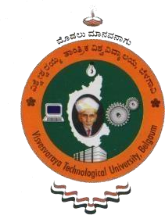
Jnana Sangama, Belagavi – 590018

A MINI PROJECT REPORT ON

“SMART HOME SYSTEM”

Submitted in partial fulfilment of the requirement for the award of Degree of

Bachelor of Engineering In
Computer Science and Engineering

Submitted by
SANGEETHA T R (4CA23CS129)
SANJANA A N (4CA23CS130)
SPOORTHI S (4CA23CS154)
SUPREETH M C (4CA23CS161)
Under the Guidance of
Prof. AMULYA K S
Assistant Professor
Department of Computer Science and Engineering


CAUVERY INSTITUTE OF TECHNOLOGY

Siddaiahna Koppalu Gate, Sundahalli Mandya – 571402
NOVEMBER - 2025

CAUVERY INSTITUTE OF TECHNOLOGY
Siddaiahna Koppalu Gate, Sunda Halli Mandya – 571402

Department of Computer Science and Engineering



CERTIFICATE

This is to certify that SANGEETHA T R (4CA23CS129) , SANJANA A N (4CA23CS130) , SPOORTHI S (4CA23CS154) , SUPREETH M C (4CA23CS161) are Bonafide students of “ Cauvery Institute of Technology ” has satisfactorily presented a mini project entitled “SMART HOME SYSTEM” in partial fulfillment of there requirements for the award of Degree of Bachelor of Engineering in Department of Computer Science and Engineering by the Visvesvaraya Technological University, Belagavi during the academic year 2025-2026

Prof.AMULYA K S  Assistant Professor Department Of CSE | Prof.RAKSHITHA B H  Assistant Professor & HOD Department Of CSE |  | Dr.SRIKANTAPPA A S  principal

